Report 1 : SqlDBM 모델링 – 20175288 최광삼
[문제 1 : Library DB]

1. relation scheme
1.1 Entity relations :
BOOK (Bid, Title, Pname* NN)
AUTHOR (Aname, Addr, Phone)
PUBLISHER (Pname, Addr, Phone)
LIBRARY (Lid, Name, Addr)
BORROWER (Card_no, Name, Addr, Phone)

1.2 Entity relations (existential dependency) : 없음
1.3 Relationship relations :
WRITES (Bid*, Aname*)
COPIES (Lid*, Bid*, No_of_copies)
LOANS (Lid*, Bid*, Card_no*, Date_out, Due_date)

1.4 Attribute relations (multi valued) : 없음

2. SqlDBM 다이어그램
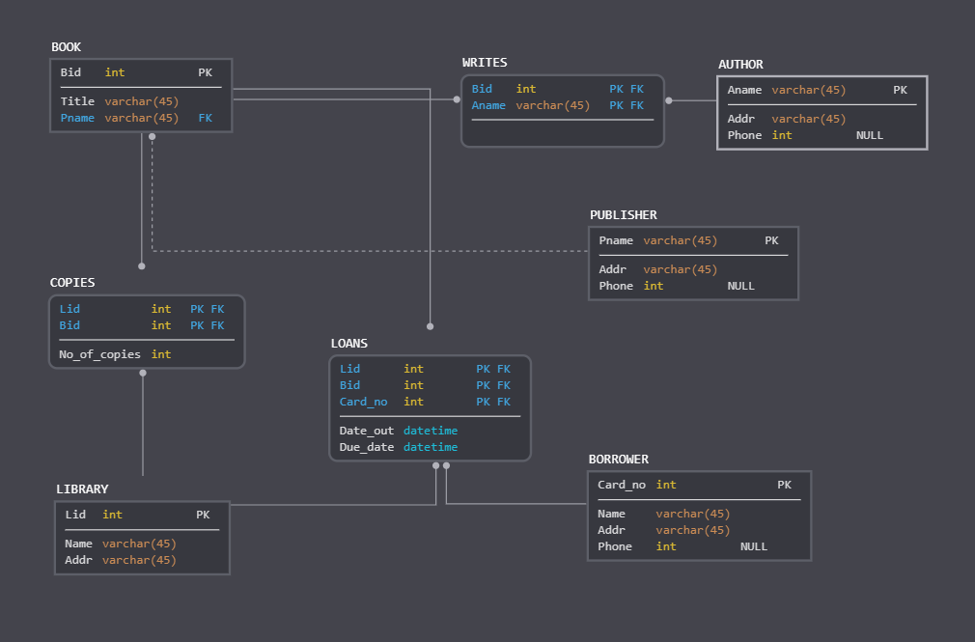
[문제 2 : Bank DB]

1. relation scheme
1.1 Entity relations :
BANK (Code, Name, Addr)
ACCOUNT (Acct_no, Balance, Type, Bank_code* NN, Branch_no* NN)
LOAN (Loan_no, Amount, Type, Bank_code* NN, Branch_no* NN)
CUSTOMER (Ssn, Name, Addr, Phone)

1.2 Entity relations (existential dependency) :
BANK_BRANCH (Bank_Code*, Branch_no, Addr)

1.3 Relationship relations :
A_C (Acct_no*, Ssn*)
L_C (Loan_no*, Ssn*)

1.4 Attribute relations (multi valued) : 없음
2. SqlDBM 다이어그램
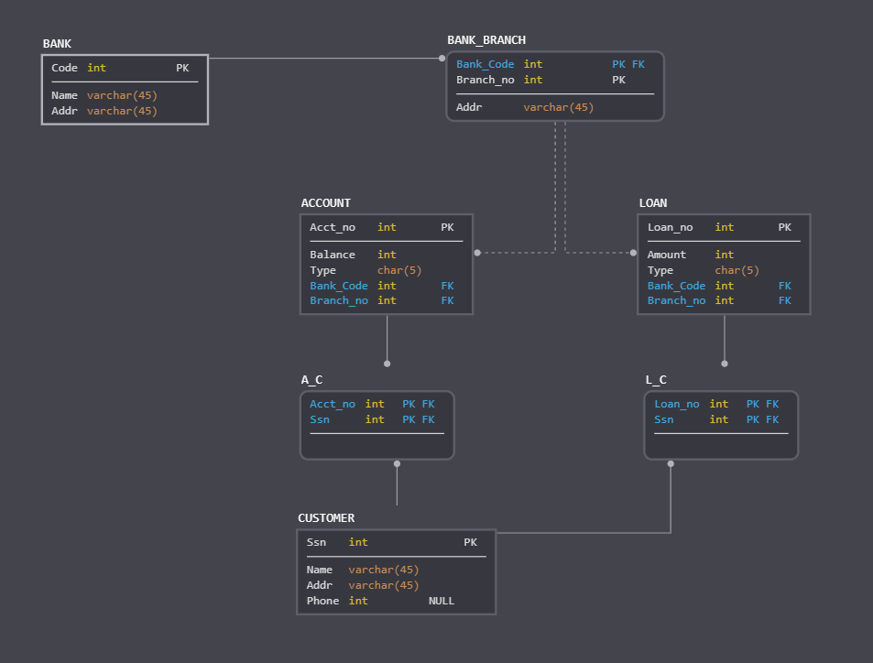
[문제 3 : Ship-Port DB]

1. relation scheme
1.1 Entity relations :
SHIP (Sname, Owner, Ship_Type* NN, SC_Name*, Pname*)
SHIP_TYPE (Type, Tonnage, Hull)
STATE/COUNTRY (Name, Continent)
SEA/OCEAN/LAKE (Name)

1.2 Entity relations (existential dependency) :
SHIP_MOVEMENT (Sname*, Date, Time, Longitude, Latitude)
PORT (SC_Name*, Pname, SOL_Name* NN)
PORT_VISIT (Sname*, SC_Name*, Pname*, Start_date, End_date)

1.3 Relationship relations :
SHIP_AT_PORT (Sname*, SC_Name*, Pname*, Start_date*)

1.4 Attribute relations (multi valued) : 없음
2. SqlDBM 다이어그램
